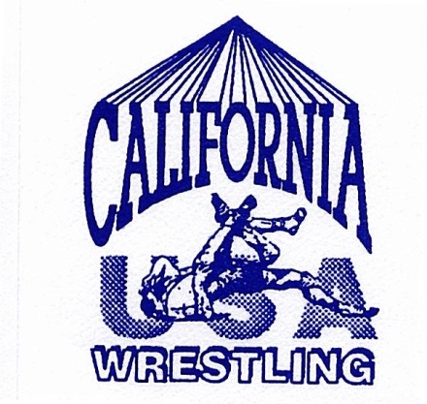

Marcie VanDusen
Women’s Director
1000 El Camino Real, Atherton, CA 94027
719-694-6509
mvandusen@menlso.edu

Cadet/Junior National Team
Medical Release

Wrestler’s Name: __________________________________________________

Address: _________________________________________________________

City: ___________________________________ Zip: _____________________

In the event of injury or illness, I hereby authorize the team leader, coaching staff, and trainers to implement
medical/or dental procedures for my son/daughter while he/she is in attendance at the training camp, the Cadet/Junior National Wrestling tournament and while in travel to and from the National tournament.

Name of Primary Insurance Co:_______________________________________

Policy Number:____________________________________________________

Signature of Parent/Guardian:_________________________________________

Date:_____________________________________________________________

In case of an emergency, I can be reached by telephone during the period of the trip at:

Home: ( )_______________________ Business: ( )_____________________

Cell: ( )________________________ Pager: ( )________________________

Please list any allergies or other known medical problems, as well as a list of any medications (including dosages) of any drugs the wrestler must take while on the trip.

Please complete and return by mail, with of your a copy Insurance card (front/back) to the address listed above.

